W-16

12 PHYSICS ATAR

TEST 8 - SPECIAL RELATIVITY

NAME: MARK: 

1. A spacecraft moving at 95.0 % of the speed of light passes the Earth on a journey to the star Lalande-21185, a distance of 8.29 light years.

***In the frame of reference of the spacecraft (experienced by the crew),*** what time and spatial measurements of the journey are different compared to those measured by an Earth based observer? Which ***TWO*** statements are correct? [2 marks]

(a) Length contraction states, ‘the path length through space is longer than 8.29 light years’.

(b) Length contraction states, ‘the path length through space is shorter than 8.29 light years’.

(c) Time dilation states, ‘the clock on earth is moving slower’.

(d) Time dilation states, ‘the clock on the spacecraft is moving slower’.

In the frame of reference of the Earth, what time and spatial measurements of the journey are different compared to those measured by an observer on the spacecraft? Which ***TWO*** statements are correct? [2 marks]

(a) Length contraction states, ‘the path length through space is shorter than 8.29 light years’.

(b) Length contraction states, ‘the path length through space will be 8.29 light years’.

(c) Time dilation states, ‘the clock on earth is moving slower’.

(d) Time dilation states, ‘the clock on the spacecraft is moving slower’.

2. Explain what is meant by the term, ***‘inertial reference frame’***. [1 mark]

3. State the two postulates of Einstein's theory of Special Relativity. [2 marks]

•

•

4. A student is travelling in a windowless carriage in an exceptionally smooth train moving at constant velocity. Is there any physical experiment she can do in the carriage to determine whether is moving? Explain your answer.

[3 marks]

5. A student is on a spaceship traveling at 0.5c away from a star, at what speed would the starlight pass the student? Explain your answer. [3 marks]

6. The time dilation effect is sometimes expressed as 'moving clocks run slowly'.

(a) Actually, this effect has nothing to do with motion affecting the functioning of clocks. What then does it deal with? [2 marks]

(b) Does time dilation mean that time actually passes more slowly in moving reference frames or that it only seems to pass more slowly? Explain your answer and give an example. [3 marks]

(c) Consider the proposed new Sydney to Perth bullet train that travels at a speed of 0.482c. A passenger on the bullet train drops a shiny stainless steel ball bearing from a height of 1.36 m.

(i) What would be the time measured by the passenger for the ball bearing to fall to the floor? [2 marks]

(ii) As the train passes through a level crossing, a stationary observer notices the ball bearing fall to the floor of the train. What would be the time measured by the stationary observer for the ball bearing to fall to the floor? [5 marks]

7. One of the biggest accelerators in the world is at CERN in Geneva, the site of the Large Electron-Positron (LEP) collider. It is 27.0 km long and accelerates the electrons (and positrons) to enormous energies in the 50.0 GeV energy range.

(a) Calculate the ‘rest-mass’ energy of a positron. [2 marks]

(b) Calculate the relativistic mass of an electron travelling along the particle accelerator with a speed of 0.99c [4 marks]

(c) What is the total energy of an electron travelling along the particle accelerator with a speed of 0.99c? [4 marks]

8. Show, by calculation, that the speed of light (c) is constant in all reference frames. Use a diagram to help explain your answer. [5 marks]

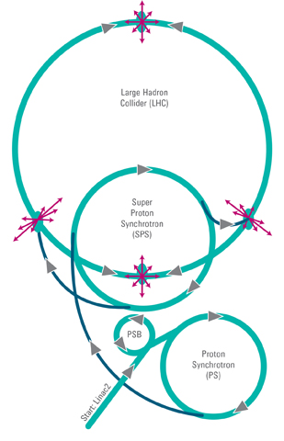

9. To enable detection of the Higgs boson, proton-antiproton collisions were produced at the LHC in CERN, Switzerland. In order to reach the enormous energies required, the particles were accelerated along the

27.0 km circumference of the LHC to reach 99.999% the speed of light.

(a) From the frame of reference of the moving particle, what is the circumference of the LHC? [5 marks]

(b) From the frame of reference of the moving particle, what happens to the area bound by the circumference of the LHC tunnel? Explain your answer. [2 marks]

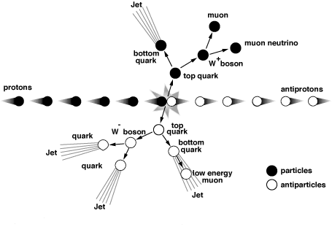

(c) A stationary observer, monitoring the particle beams from the side, noticed that the protons move with velocity of 0.80c, while the antiprotons move with a velocity of 0.60c in the opposite direction. What is the velocity of the particles relative to each other? [4 marks]